**PRACTICAL 2**

**Integer Question**

To find area and perimeter of rectangular park

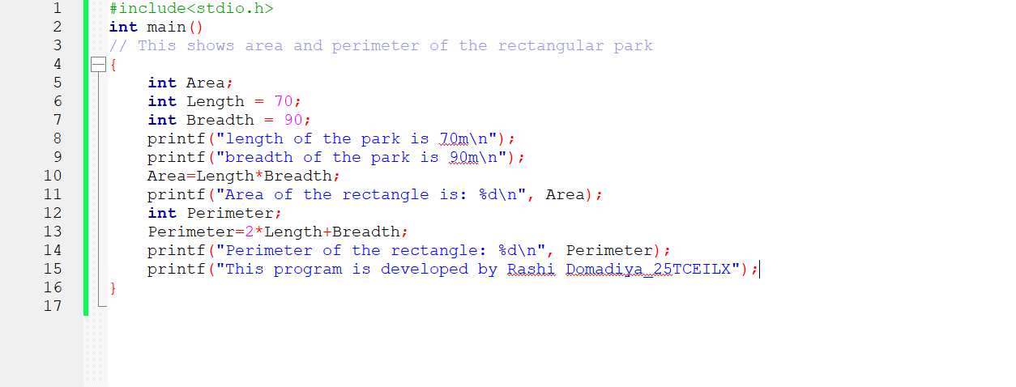

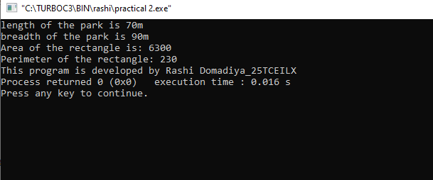

Name – Rashi Domadiya

25TCEILX